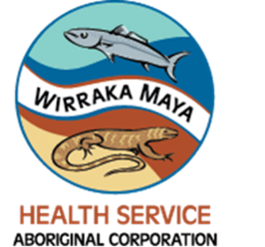PHOTOGRAPHY CONSENT FORM/MEDIA RELEASE

I, (print name) _______________________________, hereby grant permission to Wirraka Maya Health Service Aboriginal Corporation (WMHSAC), its employees or representatives, to take and use: (check all that apply)
- Photographs/digital images
- Videotape
- Audio recording or quoted remarks
- Educational or presentation materials prepared of me or by me for use in promotional or educational materials.
These materials might include printed or electronic publications, websites, social media or other electronic communications. I further agree that my name and identity may be revealed in descriptive text or commentary in connection with the image(s), video(s) and/or audio.
I agree that the media (circle one) may / may not contact me regarding my involvement with WMHSAC activities.
I authorise the use of these materials indefinitely without compensation to me. All prints, digital reproductions, video and audio recordings shall be the property of WMHSAC.
______________________
(Date)
______________________
(Signature)
______________________
(Address)
______________________
(City/Town, State, Postcode)
______________________
(Phone/Email - optional)

